Team 5 – ICT Project 2

**Reliance Fresh Indian Grocery Store**



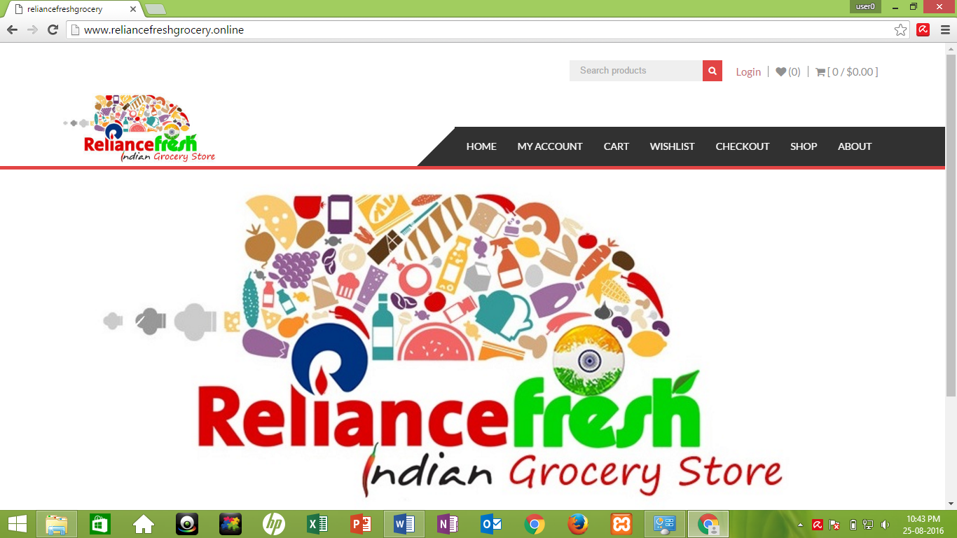

Submitted by: Team 5 Due date: 28th Aug 2016

Submitted to: Laura Antochi Submission date: 28th Aug 2016

**Table of Contents**

1. An Introduction to Team 5 (Reliance Fresh Indian Grocery Store) ……………….1

2. Beta and Final Release Deliverables…………………………………………….…4

3. User Stories log for Alpha and Beta Release with Velocity ………………………7

4. Burn-down Chart and Velocity for iteration ………………………………………8

5. ICT Advance Project 2 Beta Release Agreement …………………………………9

6. Scope of Final Release, User Story & Prototype …………………………………11

7. Project Development and Release ICT Infrastructure …………………………… 13

8. References …………………………………………………………………….......15

**1. INTRODUCTION TO TEAM-5**

This project involves a team of two members with their separate role and responsibilities of design, implementation and analysis.

Following are the details of the team members:

|  |  |
| --- | --- |
| **Name** | **Student ID** |
| Anay Vijay Gharat | 13131701 |
| Gagandeep Singh | 13126300 |

Roles and responsibilities of team members are listed in the following table:

|  |  |
| --- | --- |
| **Name** | **Roles & Responsibilities** |
| Anay Vijay Gharat | * User interface design * Meeting arrangement with client * Gather requirements from client * Selecting suitable theme & templates for website * Licence agreement with client |
| Gagandeep Singh | * Project documentation * User interface design * Database making and connectivity * Site layout |

**2. BETA AND FINAL RELEASE DELIVERABLES**

|  |  |
| --- | --- |
| **BETA RELEASE** | **FINAL RELEASE** |
| Wish list option added | Social Media Live Feeds |
| New theme selection | Google Analytics |
| Registration page upgraded | SEO |
| Website’s Logo upgraded | Bug Fixes |
| Search products button | Testing |

Following are the Screenshots of our Website upgradations which we made during BETA release as per Client and Lecturer’s advice:

**2.1 New Theme Selection:**

As our lecturer was not much happy about the theme we selected because it was not appealings, so we have changed the theme of our website. We added slide pictures of the products of store through which visitors can easily get attracted to the website and start browsing it.

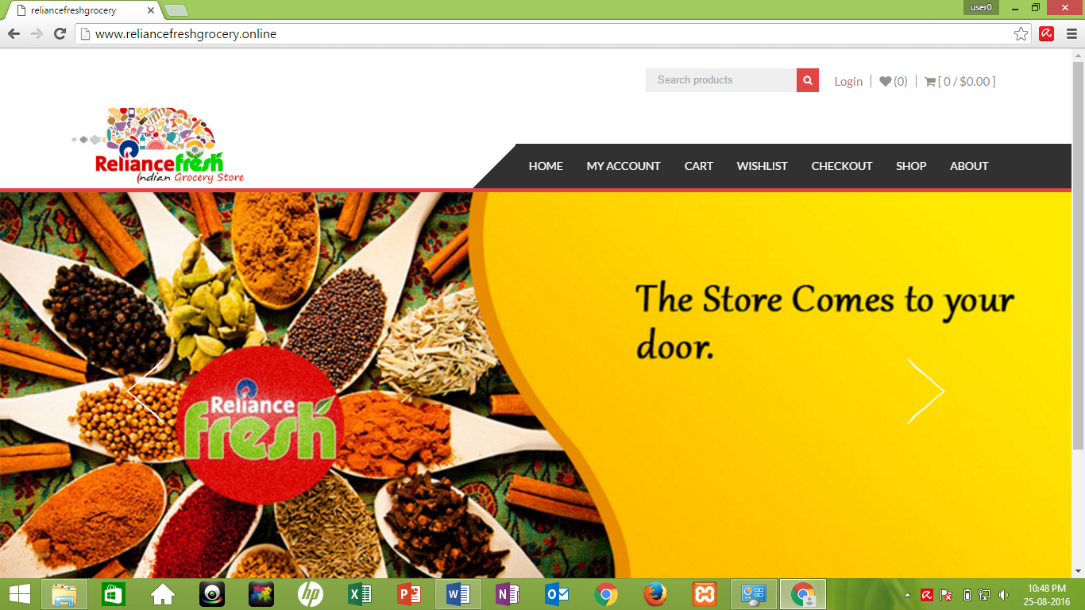

Fig: Homepage with new theme along with sliding pictures

**2.2 Registration Page**

In alpha release, it was mandatory to register on website for any purchase and there were some personal questions asked for registering. But now in Beta release we have made some changes for registering people onto website. During checkout when buyer will enter the billing details with his email ID, he can select the check option whether he want to register or not. If he selects to register, a welcome email will be sent to his email address.

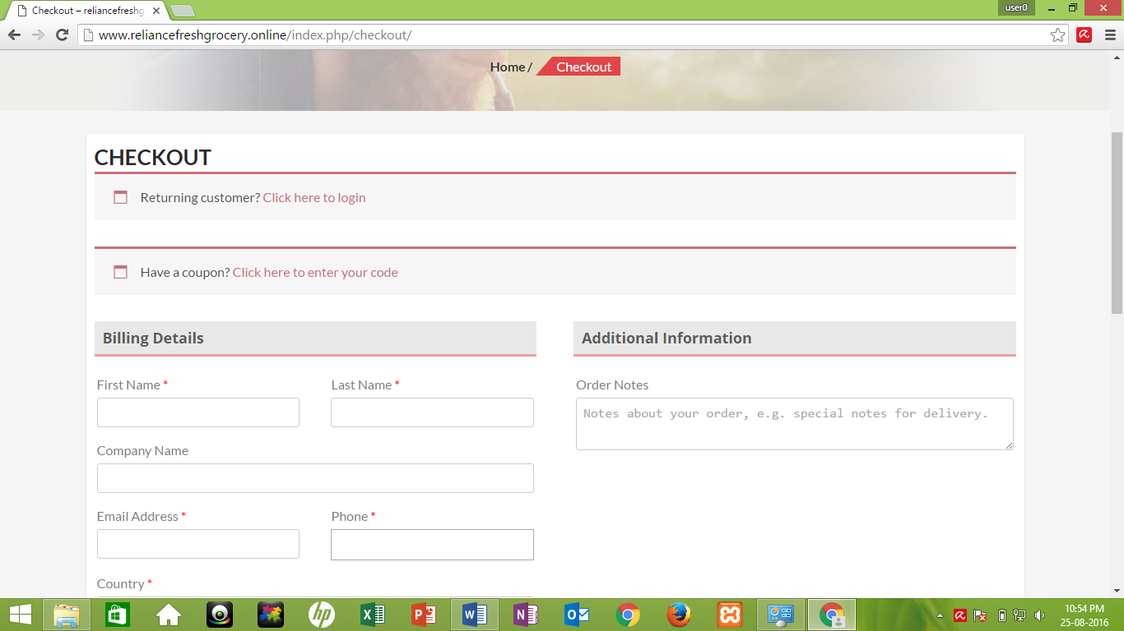

Fig: Registration cum check out page

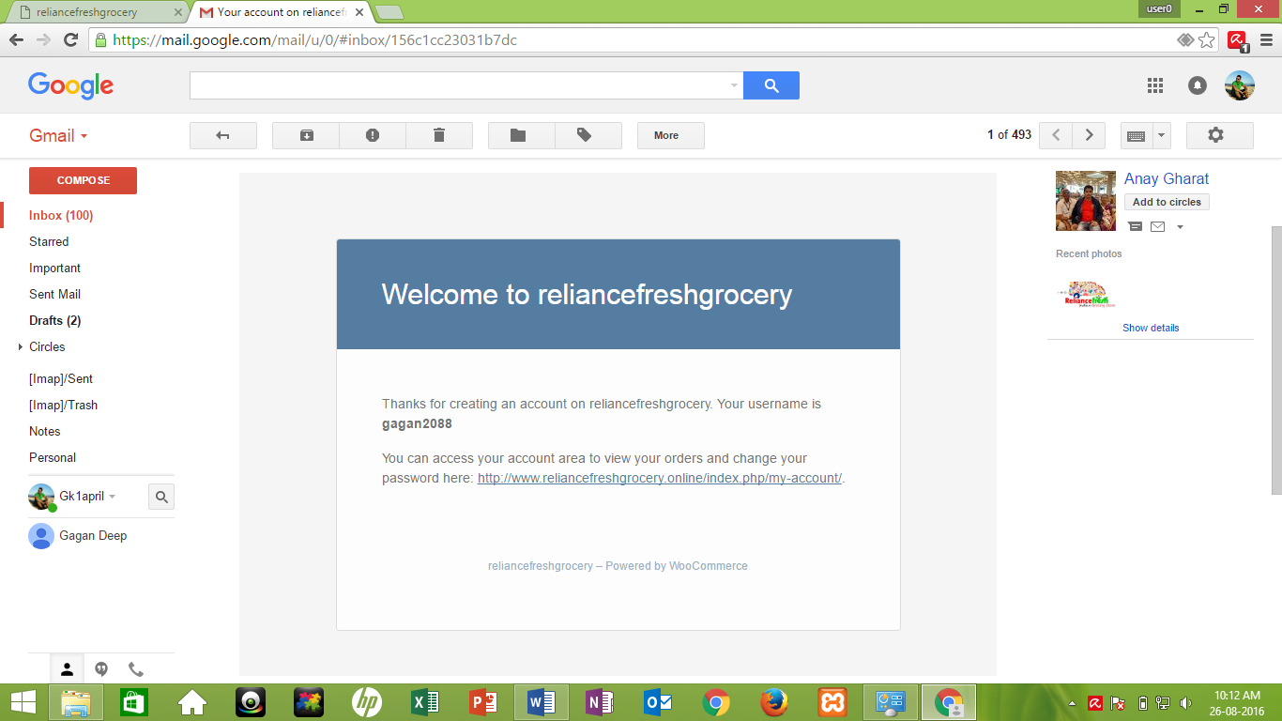

Fig: Welcome mail sent to the registered user

**2.3 Wish list Page**

New page has been added into website named “Wish list” in which all the items liked by the user will be added into wish list. After, he can select any items from his favourite list to buy.

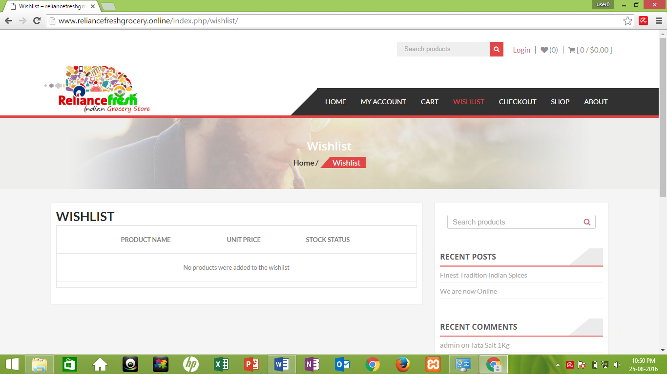

Fig: Wish list page

**2.4 Search Products**

Search engine option has been updated on the top of the website for search of any products available at the store.

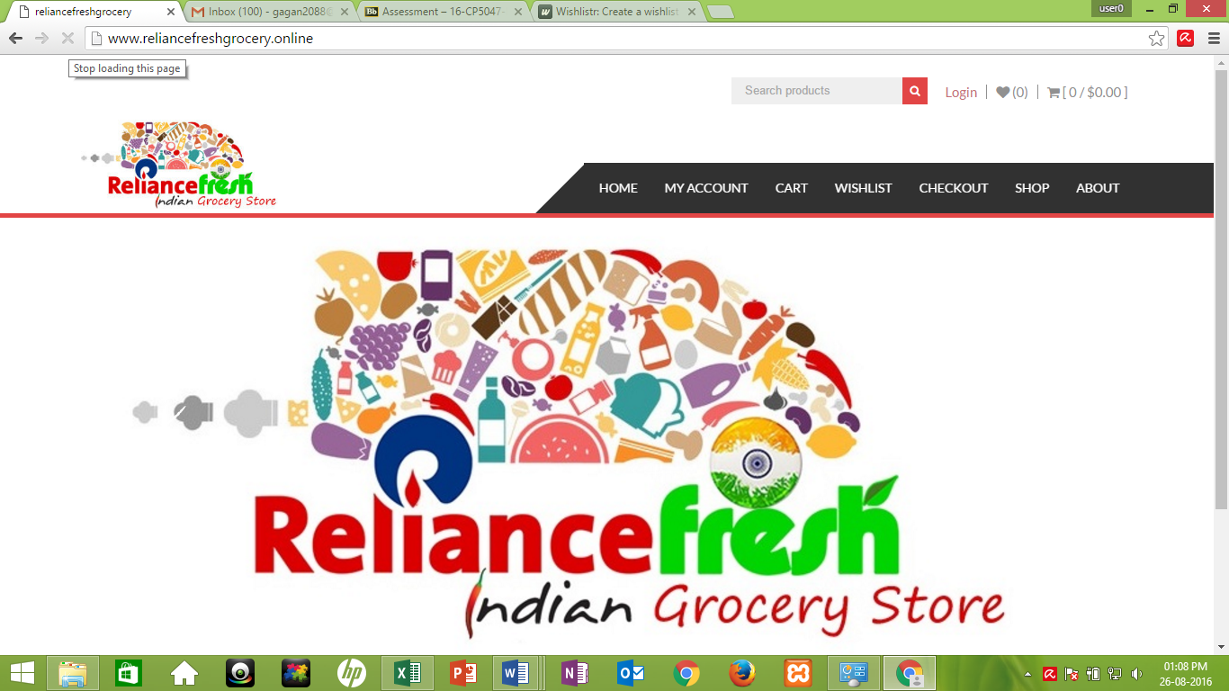

Fig: Arrow in the fig shows the Search Products facility

**3. User Stories log for Alpha and Beta Release with Velocity**



**4. Burn-down Chart and Velocity for Iteration**

We have total 5 weeks available to Go Live and Launch the official website.

3 days’ work is allotted per week

There are 2 people working in a team

Total Available Days are = 5*3*2 = 30 days

Hence, to complete all user stories the estimated time = 30 days

**Velocity** = Estimated Time / Actual Time

Estimated Time = 30 days

Actual Time = 25 days

→ Velocity = 30/25 = 120 %

|  |  |  |  |  |  |  |  |
| --- | --- | --- | --- | --- | --- | --- | --- |
| **User Stories** | **Start** | **Week 5 (in days)** | **Week4 (in days)** | **Week3 (in days)** | **Week2 (in days)** | **Week1 (in days)** | **Total** |
| **HomePage** | 10 | 2 | 3 | 2 | 1 | 2 | 10 |
| **Shopping cart** | 10 | 1 | 3 | 2 | 3 | 1 | 10 |
| **Wish List** | 10 | 0 | 4 | 2 | 1 | 3 | 10 |
| **Shop** | 10 | 1 | 2 | 3 | 4 | 0 | 10 |
| **Time** | **Start** | **Week5 (in days)** | **Week4 (in days)** | **Week3 (in days)** | **Week2 (in days)** | **Week1 (in days)** | **Total** |
| **Actual remaining (Days)** | 40 | 36 | 24 | 15 | 6 | 0 | **81** |
| **Estimated remaining (Days)** | 40 | 32 | 24 | 16 | 8 | 0 | **80** |

**5. Client Signed Acceptance of BETA Release and the Proposed FINAL Release**

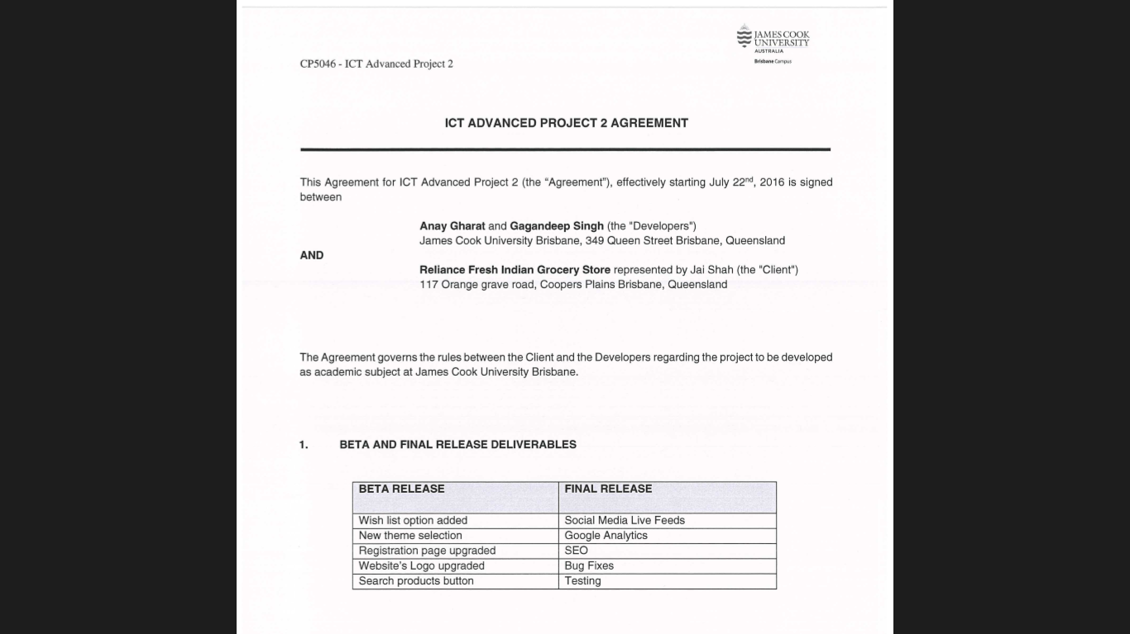

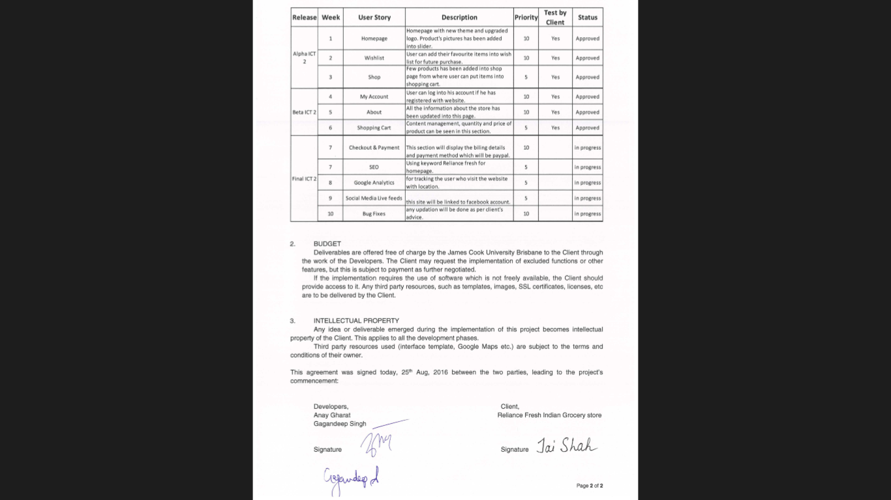

**6. Scope of Final Release, User Story & Prototype**

**User Story 1**

**Social Media Live Feeds:**

This implementation will help to display direct feeds from Facebook/Twitter to Homepage of the website.



|  |  |  |  |  |  |
| --- | --- | --- | --- | --- | --- |
| **1** | Social Media live feeds | The Live feeds from various social media like Twitter, Facebook and Instagram shall be displayed on the right sidebar of a page. | 3 | Max 7 | In Progress |

**User Story 2**

**Google Analytics:**

Google Analytics is a [web analytics](https://en.wikipedia.org/wiki/Web_analytics) service offered by [Google](https://en.wikipedia.org/wiki/Google) that tracks and reports website traffic. Google launched the service in November 2005 after acquiring [Urchin](https://en.wikipedia.org/wiki/Urchin_(software)). Google Analytics is now the most widely used web analytics service on the Internet. (https://en.wikipedia.org/wiki/Google_Analytics)

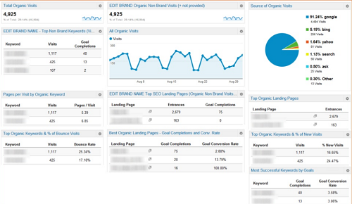

|  |  |  |  |  |  |
| --- | --- | --- | --- | --- | --- |
| **2** | Google Analytics | Integration of web analytics with your sites | 5 | Max 15 | In Progress |

**User Story 3**

**Yoast SEO (Search Engine Optimization):**

Yoast SEO (formerly known as WordPress SEO by Yoast) is the most complete WordPress SEO plug-in that exists today for WordPress.org users. It incorporates everything from a snippet editor and *real time* page analysis functionality that helps you optimize your page’s content, images titles, meta descriptions and more to XML sitemaps, and loads of optimization options in between. (https://yoast.com/wordpress/plugins/seo/)

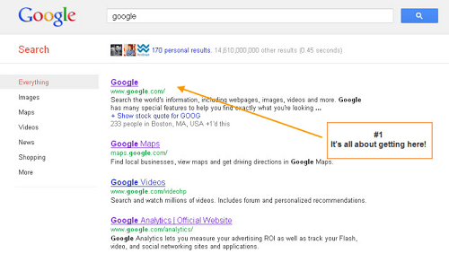

**User Story 4**

**Checkout & Payment (PayPal Express Checkout):**

PayPal Express Checkout for WooCommerce allows your customers to skip the WooCommerce checkout and use PayPal instead, taking fewer clicks across fewer screens. When customers who have a PayPal account click on the PayPal button from the shopping cart, they return with the checkout page pre-filled with information from PayPal. Fewer steps at checkout can help improve conversion up to 44%1. It’s a quick-and-easy payment solution that can help increase sales. (https://woocommerce.com/products/woocommerce-gateway-paypal-express-checkout/, 2016)

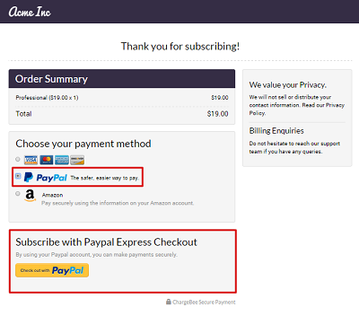

|  |  |  |  |  |  |
| --- | --- | --- | --- | --- | --- |
| **2** | PayPal Express Checkout | Billing details and payment method which will be PayPal. | 5 | Max 15 | In Progress |

**Hosting Website Live:** As our client is ready to pay for hosting and a domain name of their website, we have decided to go live at the time of final release of our project. Name of the domain is discussed and confirmed by the client. It is going to be **www.reliancefreshgrocery.online**

**Testing -** Testing of the whole website will be done with our client to check its functionality and also to confirm if any changes need to be done. In final stage of the project we will be doing a testing again and finalize the Go Live date with our client. We will also fix bugs occurred in Test 1 and then execute Test 2 to make sure that every functionality and features of a website are working as per client’s requirement.

**Bug Fixes:** In Bug fixing we are going to make sure that the website is working perfect without any giving any issues.

**Installation and Training:** In order to use and do the admin work, client will have to get some training which will help them to use both Frontend & Backend of the website. Documentation for the same will also be provided to the client for their better understanding of using a website in future.

**7. Project Development and Release ICT Infrastructure**

**Development Environment:**

**1. Word Press -(Content Management System):**

WordPress is an open source **Content Management System (CMS),** which allows the users to build dynamic websites and blog. WordPress is the most popular blogging system on the web and allows updating, customizing and managing the website from its back-end CMS and components. This tutorial will teach you the basics of WordPress using which you can create websites with ease. The tutorial is divided into various sections for convenience. Each of these sections contain related topics with screenshots explaining the WordPress admin screens. (http://www.tutorialspoint.com/wordpress/)

**2. Plug-in**:

A **Plugin** is a piece of software containing a group of functions that can be added to a **WordPress** website. They can extend functionality or add new features to your**WordPress** websites. **WordPress plugins** are written in the PHP programming language and integrate seamlessly with **WordPress**. (http://www.wpbeginner.com/glossary/plugin/)

**Programming Infrastructure:**

**PHP - Hypertext Pre-processor:**

PHP Stands for "Hypertext Preprocessor." (It is a recursive acronym, if you can understand what that means.) PHP is an HTML-embedded Web scripting language. This means PHP code can be inserted into the HTML of a Web page. When a PHP face is accessed, the PHP code is read or "parsed" by the server the page resides on. The output from the PHP functions on the page is typically returned as HTML code, which can be read by the browser. Because the PHP code is transformed into HTML before the page is loaded, users cannot view the PHP code on a page. This make PHP pages secure enough to access databases and other secure information. (http://techterms.com/definition/php)

**CSS 3 – (Cascading Style Sheet Version 3)**

Cascading Style Sheets (CSS) is a style sheet language used for describing the look and formatting of a document written in a mark-up language.

**HTML 5 – Hypertext Mark-up Language**

It is a new version of the *language* HTML, with new elements, attributes, and behaviours. **HTML5** is the latest evolution of the standard that defines HTML. (https://developer.mozilla.org/en-US/docs/Web/Guide/HTML/HTML5)

**Repository Management**

**Git Hub:**

Git Hub allows groups of people to work on the same project (often code) at the same time, and without stepping on each other's toes. It's a called as distributed version control system.

**Team Coordination Tools:**

**Learn JCU/Blackboard -** Blackboard, a virtual environment provided by James Cook University. We have used this in our project as the basic tool for sharing information such as website contents or project related documentation. We have also used this in coordinating with our teacher Miss. Laura Antochi to know the important news and updates. It is easier way to transfer files, update and communicate with team member.

**Graphics and Other Development Technologies:**

**Notepad++ :** Notepad++ is used as a tool to edit the source code of a project. It is a easy and convenient tool which allows macros editing in it.

**XAMPP -** XAMPP is the most popular PHP development environment. XAMPP is a completely free, easy to install Apache distribution containing MariaDB, PHP, and Perl. The XAMPP open source package has been set up to be incredibly easy to install and to use. (https://www.apachefriends.org/index.html)

**Photoshop -** Photoshop is one of the best software for high quality picture editing. We have used Photoshop in our website project to create the Logo, Sidebar images and also to edit the photos.

# References:

*http://techterms.com/definition/php.* (n.d.). Retrieved from http://techterms.com.

*http://www.tutorialspoint.com/wordpress/.* (n.d.). Retrieved from http://www.tutorialspoint.com/.

*http://www.webopedia.com/TERM/S/SEO.html.* (n.d.). Retrieved from http://www.webopedia.com/.

*http://www.wpbeginner.com/glossary/plugin/.* (n.d.). Retrieved from http://www.wpbeginner.com/.

*https://developer.mozilla.org/en-US/docs/Web/Guide/HTML/HTML5.* (n.d.). Retrieved from https://developer.mozilla.org.

*https://en.wikipedia.org/wiki/Google_Analytics.* (n.d.).

*https://woocommerce.com/products/woocommerce-gateway-paypal-express-checkout/.* (2016). Retrieved from https://woocommerce.com/.

*https://www.apachefriends.org/index.html.* (n.d.). Retrieved from https://www.apachefriends.org.

*https://yoast.com/wordpress/plugins/seo/.* (n.d.). Retrieved from https://yoast.com.

W3C. (2015). Retrieved from http://www.w3schools.com/css3_intro.asp